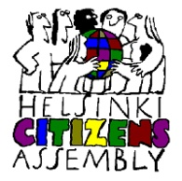
Presentation and discussion based on the report:
"The Situation on Human Rights Violations of Conscripts and Servicemen regarding Medical Services”

Agenda

Best Western Congress Hotel, Ball room
1st Italy Street, Yerevan

December 21, 2012
12:00 – 12:10  12:10 – 12:20 | Registration of participants  Opening remarks  Larisa Minasyan, Open Society Foundations-Armenia  Artur Sakunts, Helsinki Citizens' Assembly – Vanadzor Office  Moderator  Avetik Ishkhanyan, Helsinki Committee of Armenia (tbc)
12:20 – 12:50  12:50 – 13:00  13:00 – 14:00 | Speakers  Artur Sakunts, Helsinki Citizens' Assembly – Vanadzor Office  Arayik Zalyan, Legal Expert, Helsinki Citizens' Assembly – Vanadzor Office  Artur Minasyan, Medical Expert  Documentary Screening: “Don’t count me absent” HCAV  Mushegh Shushanyan, Attorney  Discussion-debate

